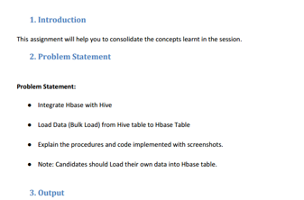

**FROM HBASE TO HIVE**

**Creating table in hbase and inserting records**

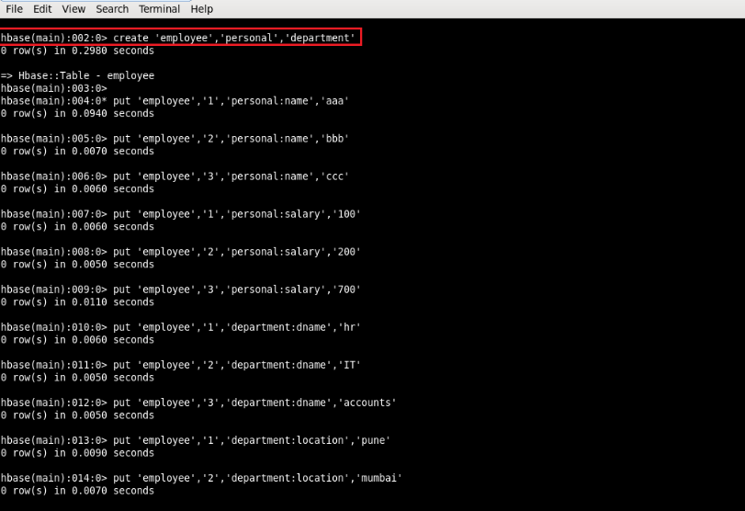

**Displaying records in hbase table**

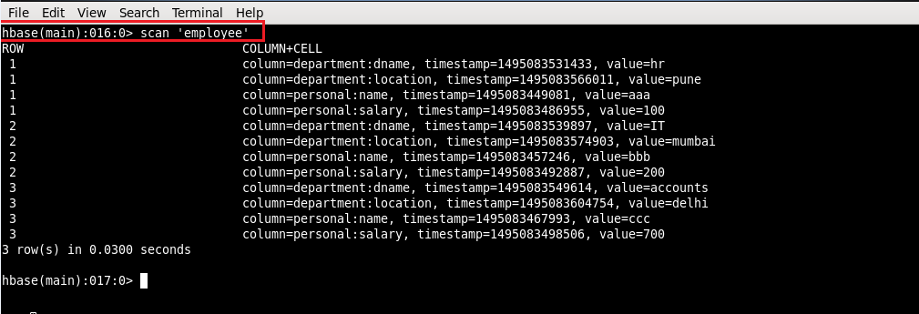

**Integrating hbase and hive. Creating an external table in hive which will import data from hbase table**

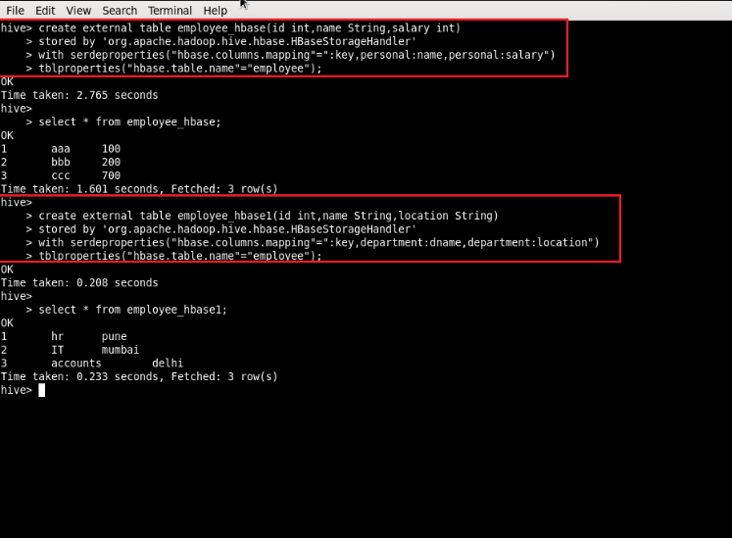

**FROM HIVE TO HBASE**

**Creating table in hbase**

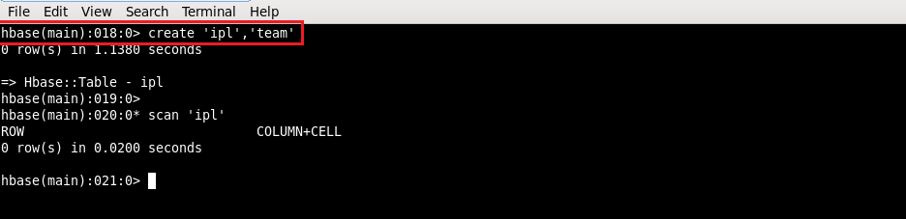

**Creating table in hive so that it is integrated with hbase**

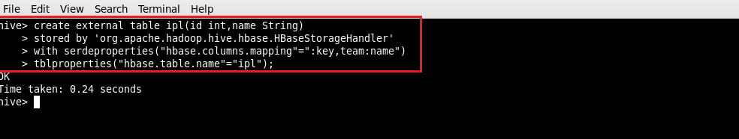

**Displaying the contents of table in hive**

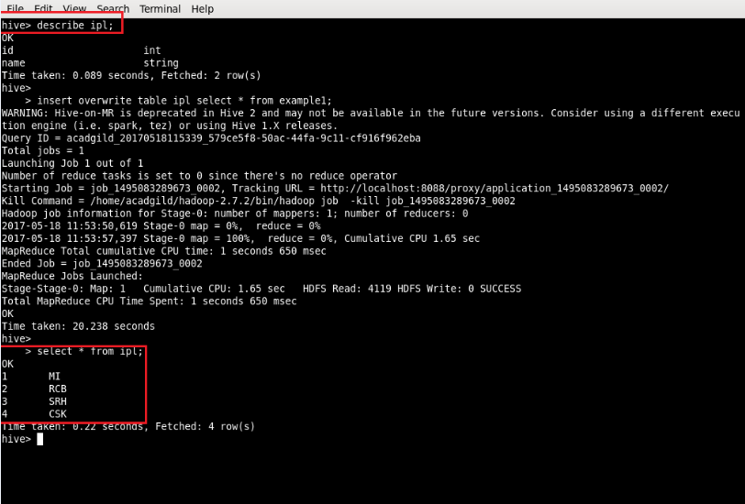

**The contents of the table in hive are loaded into table in hbase**

